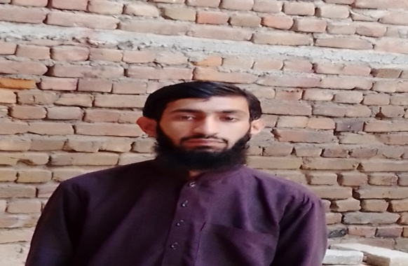
M.Hamza Hashmi
Adress City =Near EME College Peshawar Road Street no 7 New faisal colobny Islamabad
Contact no: 03348529804
Email: Hamzahashmi36@yahoo.com

OBJECTIVE
Experienced clerk with excellent communication and time management skills. Interested in the position of Office Clerk, bringing proficiency in Excel; ability to handle high volume calls; ability to keep inventory of supplies; and superior clerical skills to perform general administrative duties.
EDUCATION
Intermediate | Fbise Board Islamabad
Matric | Fbise Board Islamabad

SKILLS
- Ms office
COURSES
- Computer course of three months
WORK EXPERIENCE
- Fresh
PERSONAL INFORMATION
Father Name | Muhammad Saifullah Hashmi
Date of Birth | 08/08/1998
CNIC No | 61101-3942803-3
Gender | Male
Nationality | Pakistani
Religion | Islam

